HOSTEL WEBSITE PROCESS:

1. Finalize a design and divide the components.

<https://webflow.com/made-in-webflow/website/racek> - great design overall features can be picked up

<https://webflow.com/made-in-webflow/website/pousada-costao-dos-ingleses> - can pick the review component

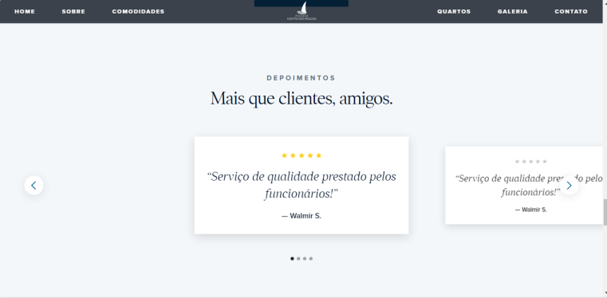

<https://webflow.com/made-in-webflow/website/tucu> - Faq, typing text, sliding gallery, categories with description on hover, reviews with images.

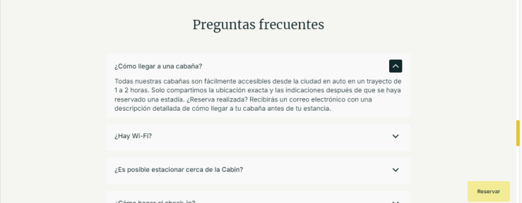



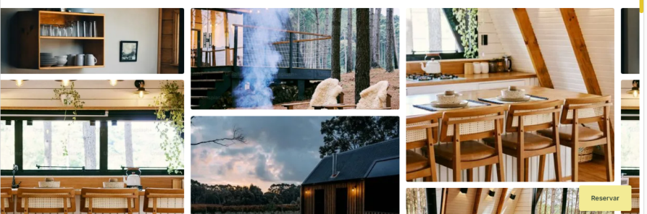

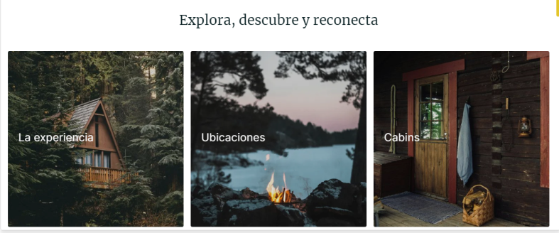

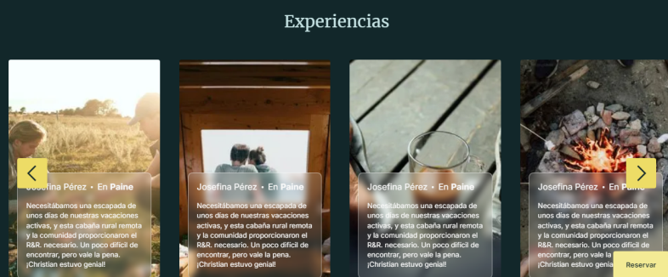

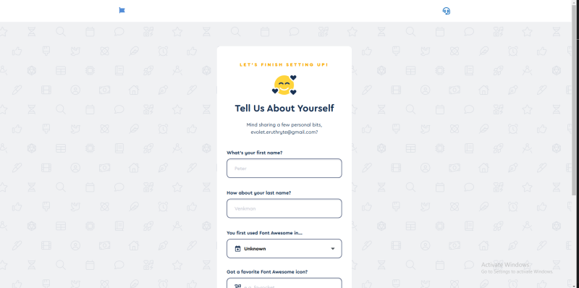

References:

<https://www.ubytovani-racek.cz/>

<https://pousada-costao-dos-ingleses.webflow.io/>

<https://tucu.webflow.io/>

**Assets:**

Choose fonts to be used - <https://fonts.google.com/specimen/Trochut>

All Images throughout the site, their cartoonized version

Logo

Favicon

Development guidelines:

For production - <https://legacy.reactjs.org/docs/optimizing-performance.html>

Accessibility - <https://legacy.reactjs.org/docs/accessibility.html>

lazy loading, fallback, code splitting - <https://legacy.reactjs.org/docs/code-splitting.html>

Error boundaries - <https://legacy.reactjs.org/docs/error-boundaries.html>

2. Create react app and initialize git repo

npx create-react-app my-app

<https://medium.com/@regondaakhil/pushing-your-first-react-app-to-github-a-step-by-step-guide-f7b592e67658>

3. Create common components to hold application

Add favicon - done

Redirection - done

Error boundary - <https://legacy.reactjs.org/docs/error-boundaries.html> - done

Redux to maintain application state

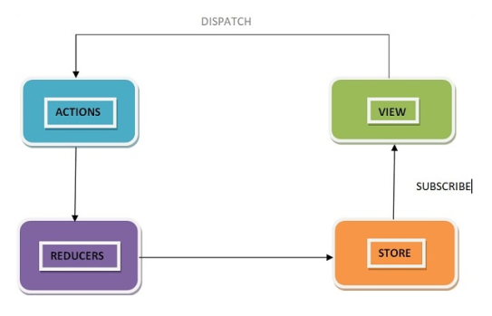

Common style sheet

Scroll bar design change

4. Individual components – Header

5. Footer

6. Hero Banner

7. Galleries

8. Room types

9. Amenities in hostel

10. Local amenities

11. Reviews – with and without images & FAQs

12. Map to show locations

13. Contact us form with mail feature

14. See vacancies and availability

15. Admin/ User Login and verify account with different methods

16. Hosteller joining form with all details and regulations with welcome mail

17. Admin portal to perform CRUD operation on stored data, update hostel availability

18. Update all details – partial authoring of data

19. SEO

20. Cookies & Tracking